Install Droid CLI Mode
- Refer Welcome to Factory - Factory Documentation
- Go to CLI >> Quickstart >> copy the code for your machine (for windows machine copy this code)
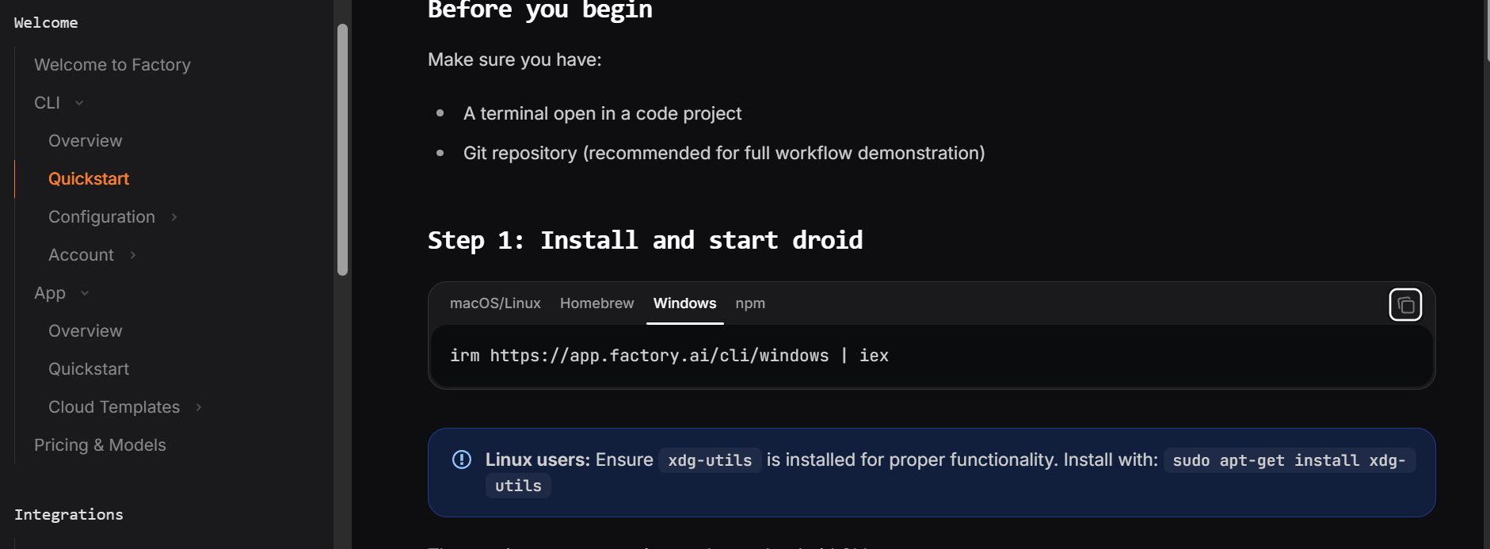
- Go to powershell and paste the code
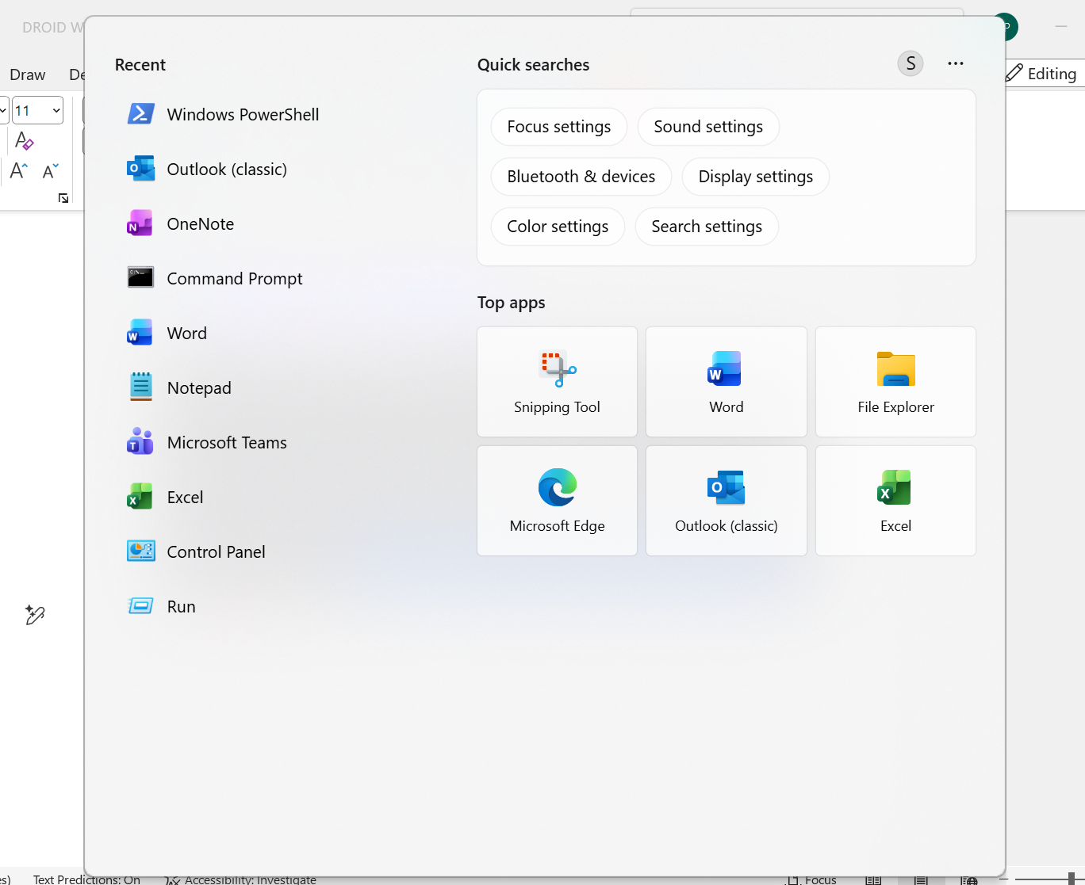
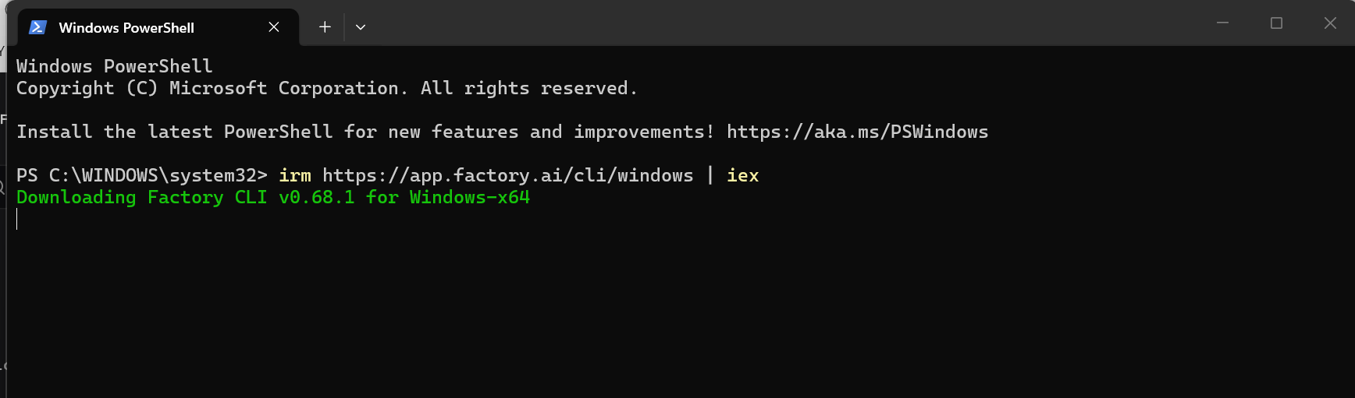

- Droid installed
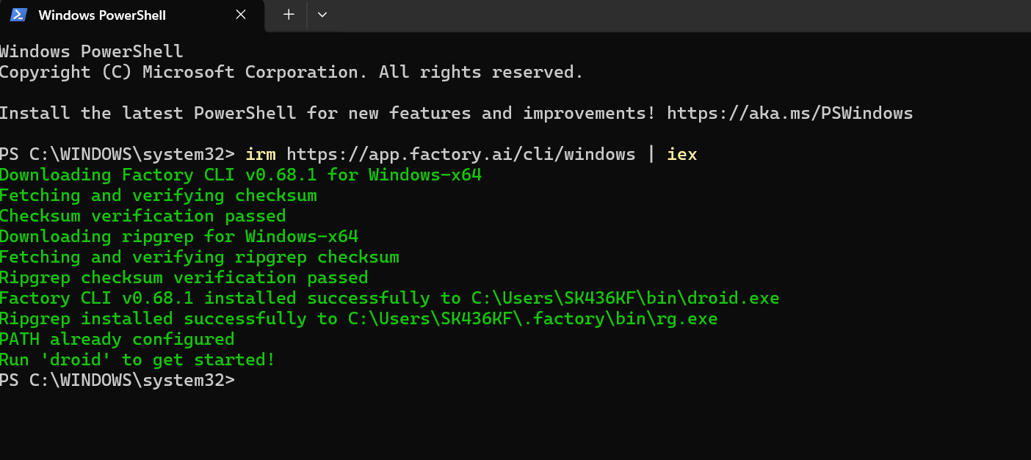

DROID is installed

Install Droid extension in VS CODE

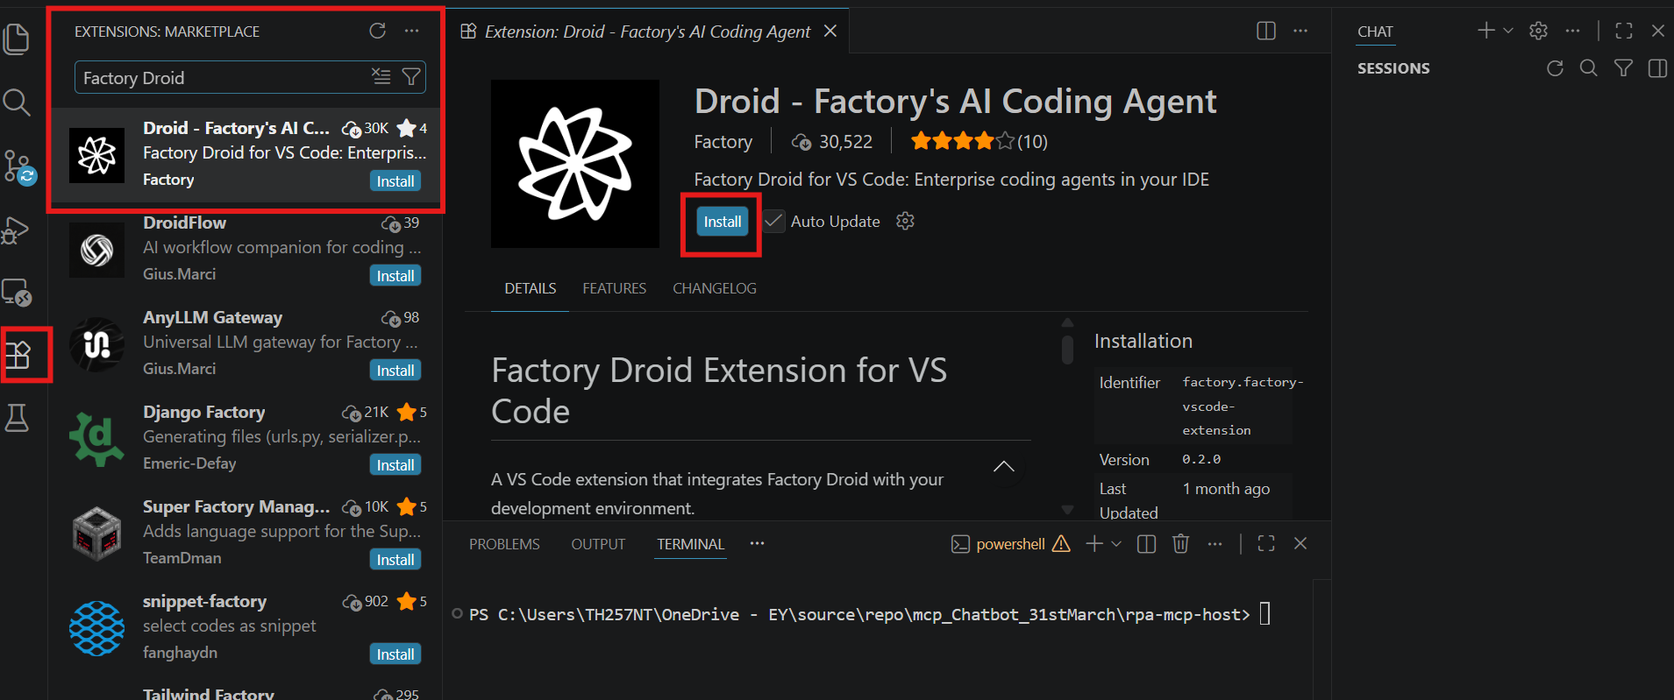
1. Click on Install
2.Installation Completed. Now click on the droid icon as highlighted or give the command CTRL +SHIFT+P -> Now select RUN DROID
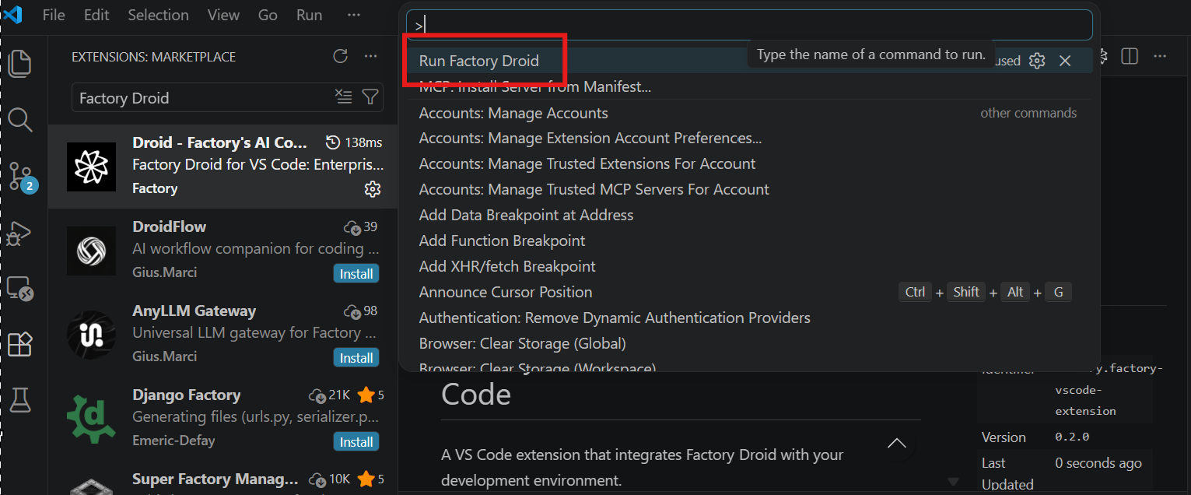
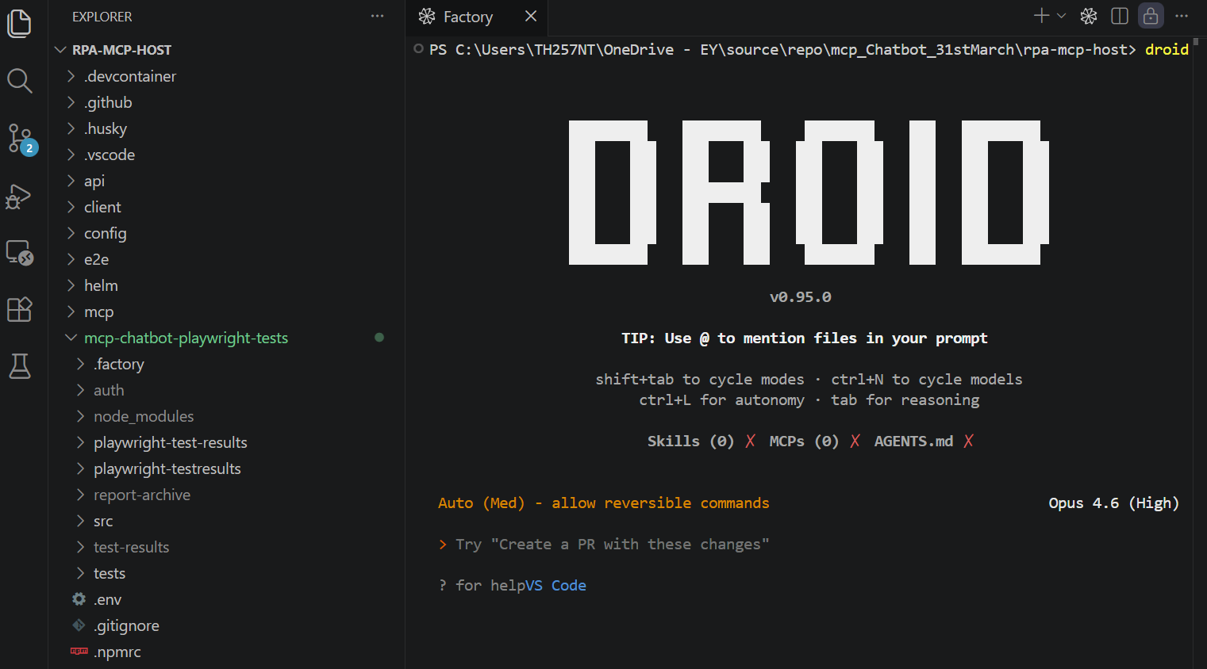
Add Playwright MCP Server Plugin
1. Type /mcp and then select the Manage Server option by ENTER key

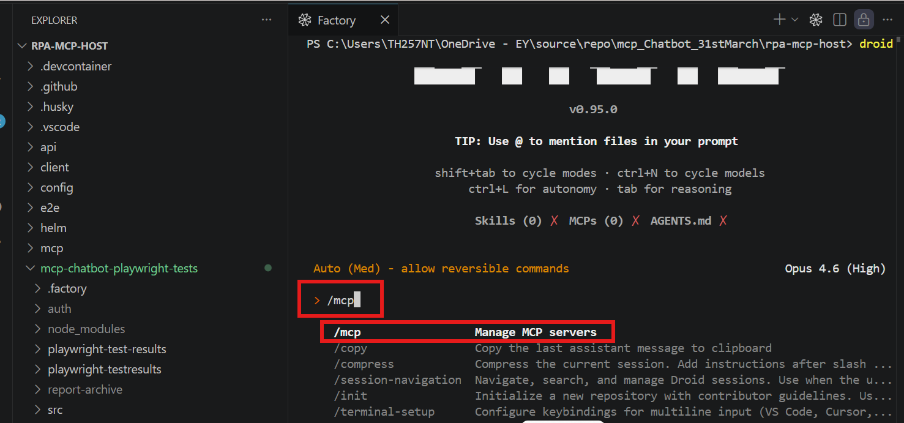
2.Put down arrow to navigate and select MCP server from registry option
3. Click enter
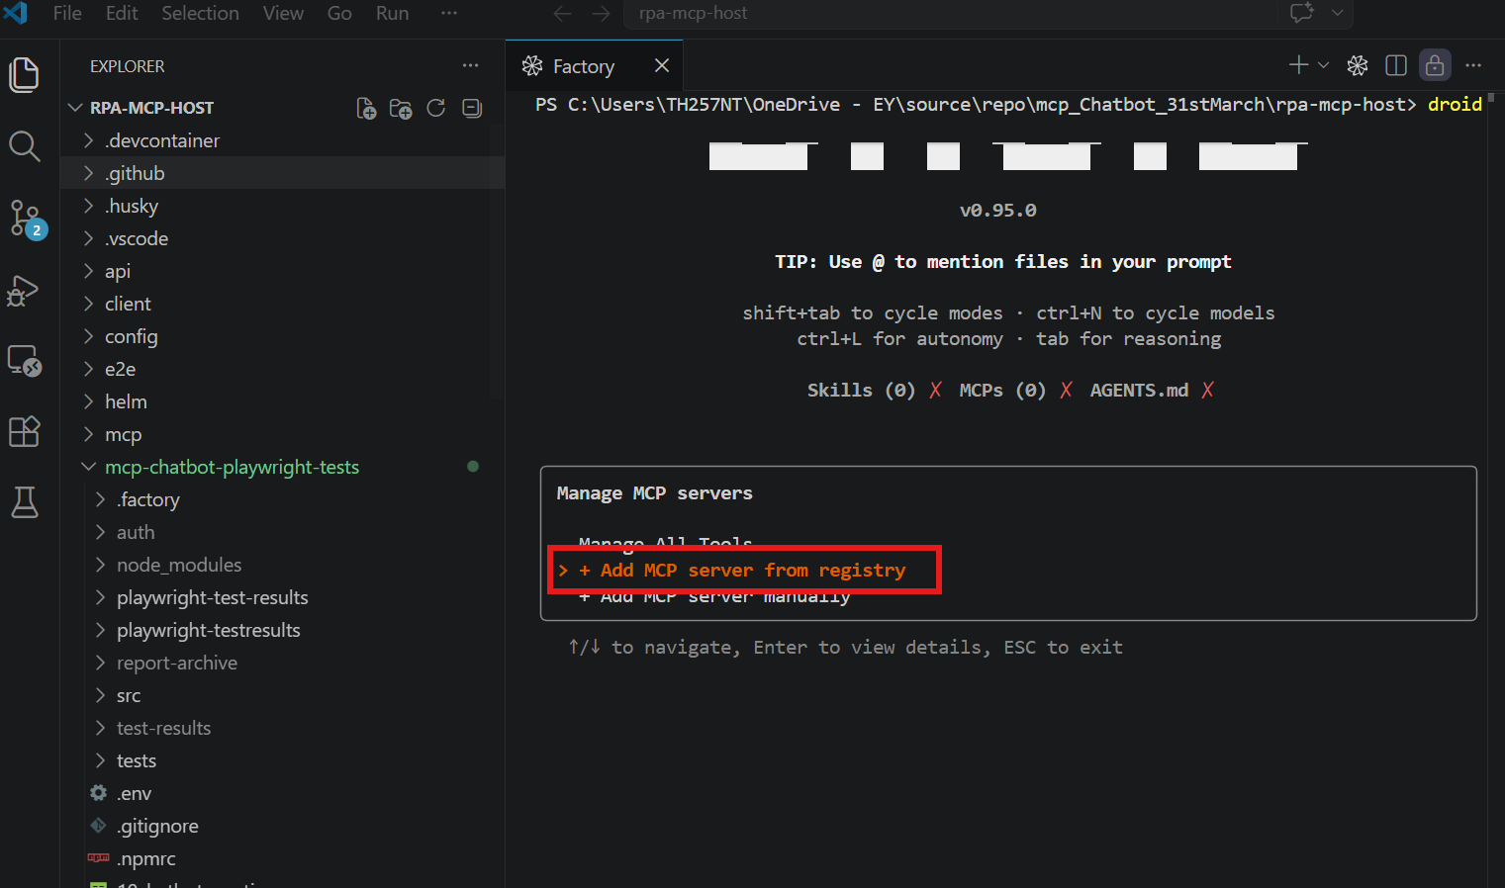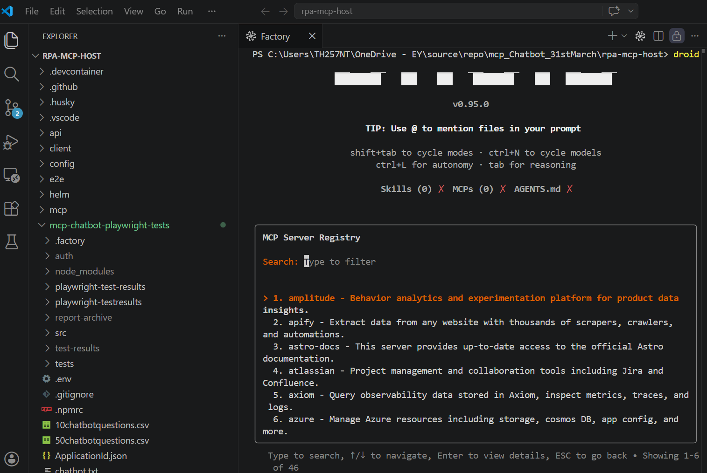
4.Now type Playwright in the Search area
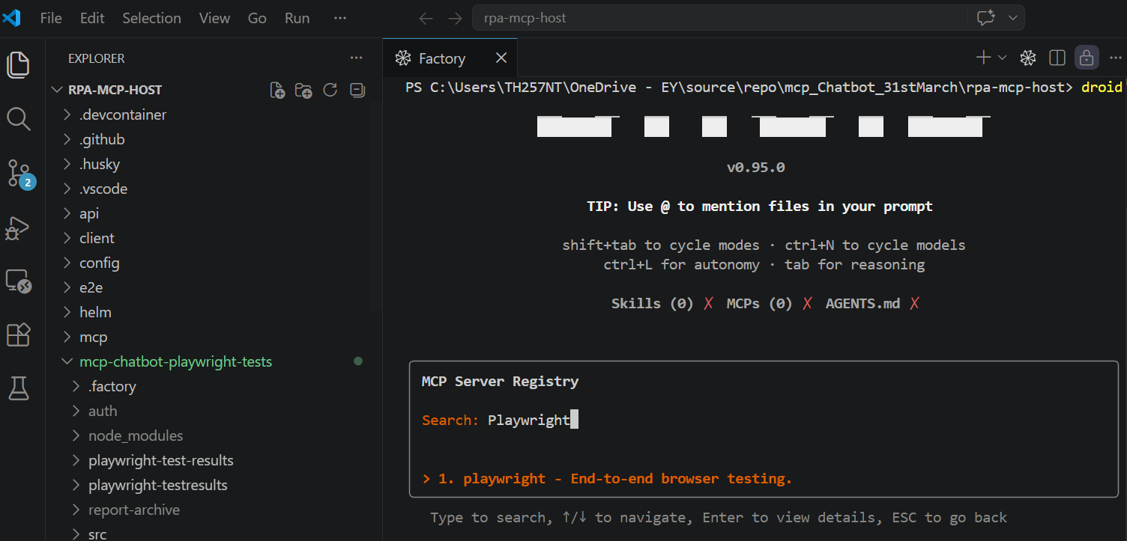
5.Enter to install
6. Select Add Server to continue
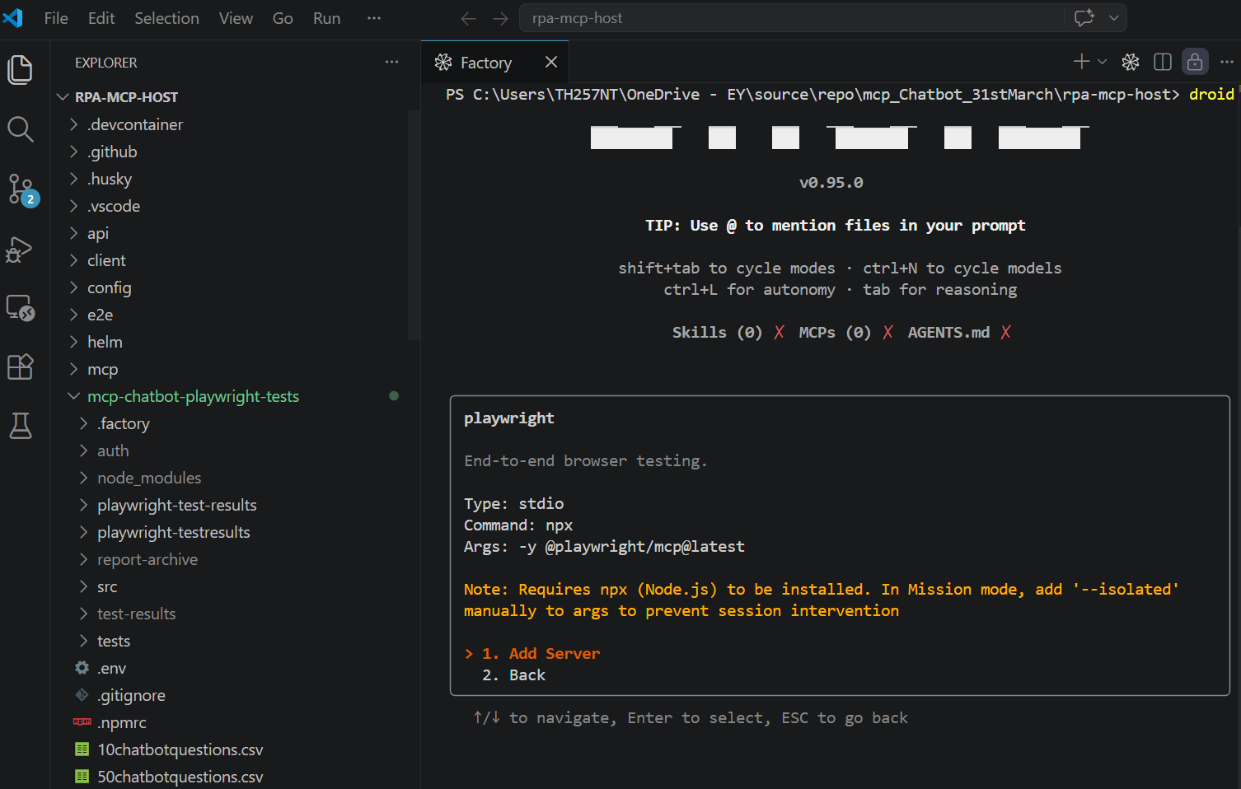
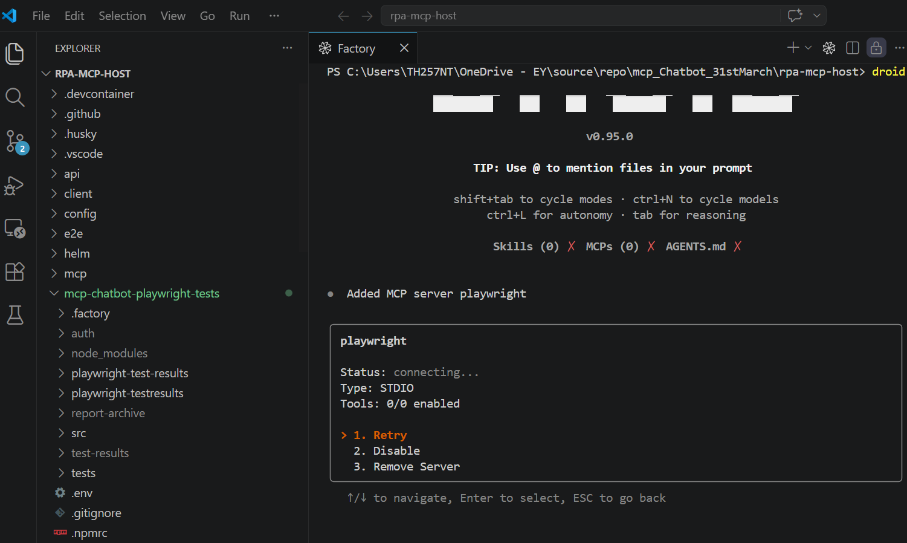
Connected
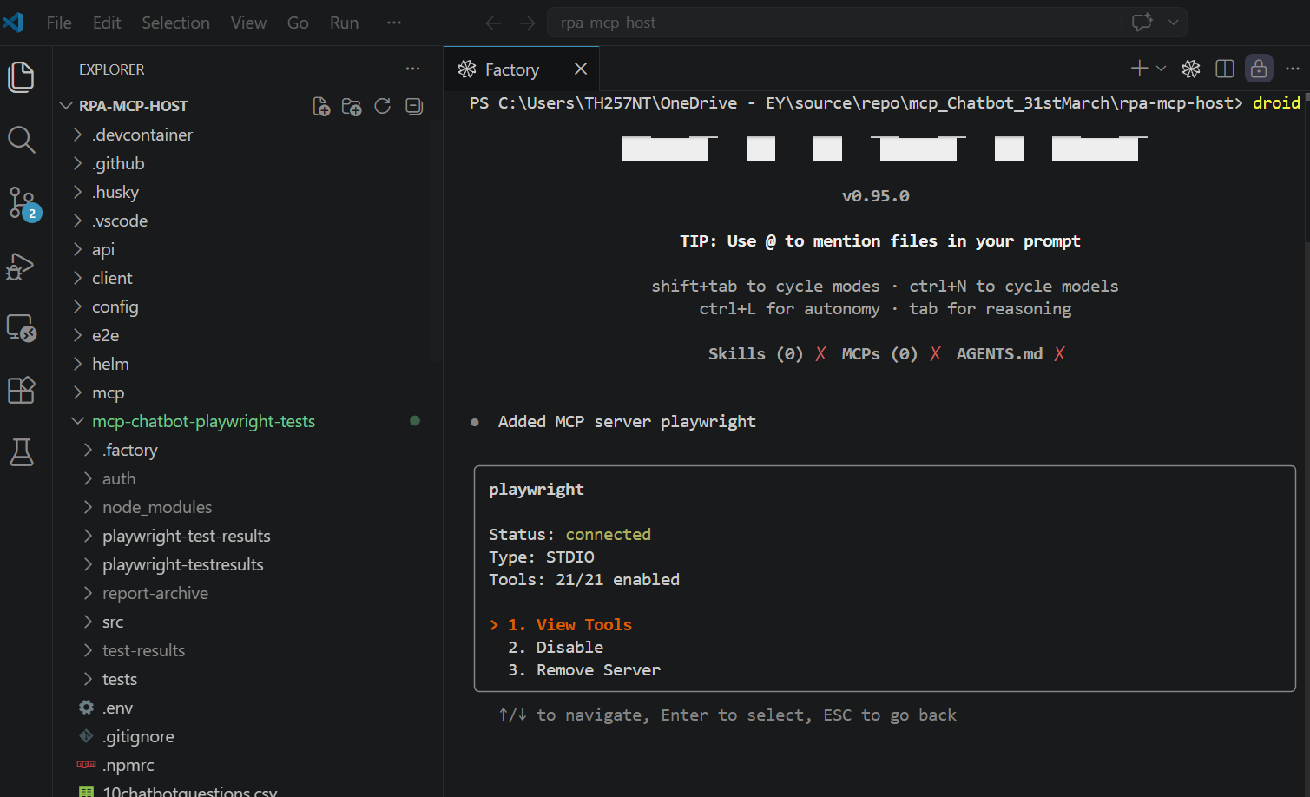
7.Restart the droid to initialize MCP server
